Author’s Name
Institutional Affiliation
Date

Part A
Tuf, I. H., Drábková, L., & Šipoš, J. (2015). A personality affects the defensive behaviour of Porcellio scaber (Isopoda, Oniscidea). ZooKeys, (515), 159.
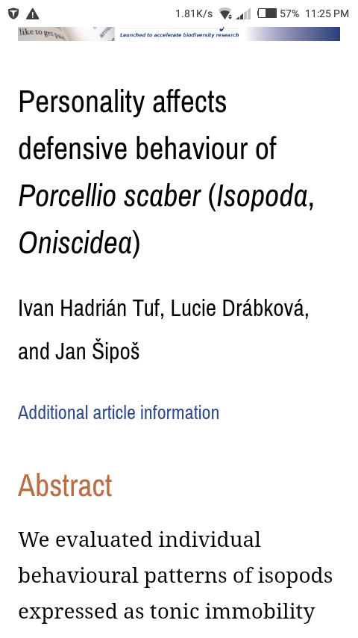
This study accessed the tonic immobility of woodlice, Porcellio scaber, following some treatments. They were placed separately in boxes and analyzed for tonic immobility (TI) frequently (Tuf, 2015). There was an evaluation of endurance, sensitivity, and reactivity of the stability based on three kinds of treatments; drop, squeeze and touch. Drop and squeeze caused TI more repeatedly while the delicate procedure was touch hence repeated severally to get a reaction. Nonetheless, the time of reaction continued for a prolonged duration with touch. The time of the response was influenced by the size or death of some of the creatures. The research discovered crucial discrete endurance patterns of TI that were steady across treatments and across time.
Rahbar, G., Kowsar, A., & Azimi, M. (2015). A bioassay of sow bugs, burrowed matter utilizing barley and wild rye. In the Second National Conference on Desert, Semnan
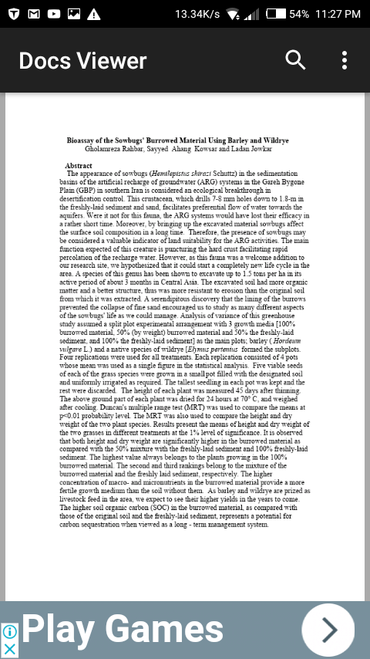

The existence of sow bugs in the artificial recharge of groundwater (ARG) systems in Iran is perceived as an ecological discovery in desertification management (Rahbar, 2015). This creature drills as from approximately seven millimeters to two meters in the sand and sediment. This drilling causes preferential water-flow towards aquifers. The systems would otherwise have to be extinct long time ago. Moreover, sow bugs have an impact on the soil composition by raising the excavated matter. The existence of sow bugs is a valuable sign of land fitness for ARG operations since it means that the land is moist which one of the characteristics of fertile land. The primary role of sow bug is penetrating the firm crust allowing fast percolation of the refreshed water. Nonetheless; as this creature was new to the study's site, it was hypothesized that it could begin a new life cycle. The species has been indicated to dig up to one tonne for every hectare when active for three months in central part of Asia. The dug soil contained an excellent structure, and organic material hence was more unsusceptible towards erosion compared to the original soil from which it was dug. The discovery of burrows hindering the disintegration of fine sand motivated the study of various perspectives of a sow bug’s life. The study assumed an experimental arrangement that was a split plot with three growth cultures. The cultures included a hundred percent fresh sediment, fifty percent fresh sediment and a hundred percent burrowed matter. The subplots were barley and species Elymus pertenius. All treatments had four replications. Every replication had four pots whose average was applied as one numerical in statistical analysis. The course fluid that dries quickly and creates a rigid tube which functions as an access point to sow bugs has an impact on the composition of burrowed matter. The study also involved the possible effects of this creature to fertility, and hence ecology and productivity of the place. Results indicated that sow bugs help in improving the soil productivity and fertility by mixing the different layers of the soil.

Forsman, A. & Sunde J. (2016). The mate selection is inconsistent with the short-term impacts of a woodlouse’s intraspecific admixture. The Biological Journal of the Linnean Society, 119(2), 359-369.
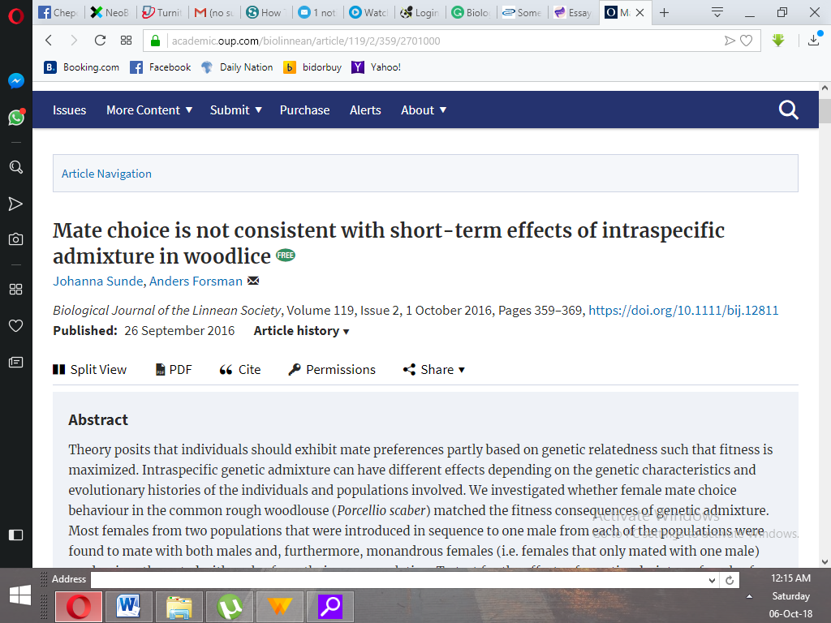

Theory suggests that individuals must portray mate preferences with regards to genetic connection to maximize fitness (Sunde, 2016). Intraspecific admixture can have various impacts based on the evolutionary histories a genetic characteristic of populations and individuals involved. Anders and Johanna studied as to whether a woman's mate selection behavior by the woodlouse called Porcellio scaber, equaled fitness results of the admixture. Majority of the women who were from tandem community which were presented in a series for a single male from every community were discovered to breed with all males. Moreover, monandrous females predominantly produced with males who originated from communities similar to them. Monandrous females are females that only produced with a single male. Females who came from quartet communities were split into duplicate and given to breeding with a male from an admixed community or a male from a similar community as the female to analyze the impacts of genetic admixture. The impact of breeding treatment on female proportions that hatched young and produced eggs relied on woman pedigree community. The breeding treatment indicated opposing impacts in other cultures while there lacked detectable implications in the others. By expectations to contract, the breeding patterns unmatched the observed effects of the admixture.

Part B
Woodlice are usually restricted to areas where are damp, and there is minimal saturation deficit. Cylisticus convexus are found in wet habitats. I decided to study their moisture responses since it was easy to see these creatures. I wanted to explore their behaviors under distinctive humidity conditions to know their ideal scope of humidity. I kept four grown Cylisticus convexus in two different olfactometer chambers. I pumped moist air via the instrument for four minutes prior to keeping the creatures and three minutes after they were inside. I created moist air by passing air through salt, acid and aqueous solutions. The experiment began after pumping moist air via one chamber. I observed for any changes at thirty-second intervals. The oscillated the air-flow between rooms every ten minutes. Three checks were carried out first to regulate the readings on the chamber. The isopoda responded differently after being exposed to different humidity. Humidity alternations between the rooms invariably led to behavioral changes. The creatures that I submitted to zero humidity were moving hectically. This reaction shows a severe adverse condition. When I subjected them to high humidity, they walked around like there unfavorable conditions. Nonetheless, the movements were not as hectic as for those who were in dry conditions. There was grouping in low and high humidity, but lasted less under high humidity. The creatures probably grouped at minimum moisture to minimize the water-loss rate. The animals moved about steadily at mid-range conditions indicating a fit environment. Grouping at times happened although most regularly towards the end of the experiment. They could have done so to preserve the moisture, though most probably it was thigmotactic reactions because of no hiding places. Others were against the chamber’s curved side, apparently also reacting to thigmotaxis. Isopods will utilize or aggregate an area to fulfill this response if hiding areas are unavailable. Humidity is unable to describe the moisture.

References
Tuf, I. H., Drábková, L., & Šipoš, J. (2015). Personality affects defensive behaviour of Porcellio scaber (Isopoda, Oniscidea). ZooKeys, (515), 159.

Rahbar, G., Kowsar, A., & Azimi, M. (2015). Bioassay of sowbugs, burrowed material using barley and wildrye. In Second National Conference on Desert, Semnan

Sunde, J., & Forsman, A. (2016). Mate choice is not consistent with short-term effects of intraspecific admixture in woodlice. Biological Journal of the Linnean Society, 119(2), 359-369.

